Patient Assessment Documentation Package (PADP)

C3-C1 Conversion Project

Interdisciplinary Plan of Care User Manual
for NUPA Version 1.0



April 2012

Department of Veterans Affairs
Office of Information and Technology (OIT)
Office of Enterprise Development (OED)

Revision History
Date | Revision | Description | Author
May 2010 | 1.0 | Initial version for v1.0 | CBeynon
August 2010 | 1.1 | Add content | CBeynon
August 2010 | 1.2 | Format content | CBeynon
September 2010 | 1.3 | Split manual into three manuals  Interdisciplinary Plan of Care  User Manual  Changed dates to October | CBeynon
October 2010 | 1.4 | Updated according to comments from the WPR | CBeynon
November 2010 | 1.5 | Prepped for release | CBeynon
February 2011 | 1.6 | - Changed dates to February 2011  - Updated with comments from Judy | CBeynon
March 2011 | 1.7 | - Changed dates to April 2011  - Updated with Judy’s comments | CBeynon
April 2011 | 1.8 | Updated RoboHelp with this file | CBeynon
May 2011 | 1.9 | - Changed dates to May 2011  - Added (NUPA*1) namespace | CBeynon
October 2011 | 2.0 | - Added C3-C1 Conversion Project  - Changed dates to October 2011  - Prepped for national release | CBeynon
November 2011 | 2.1 | - Changed dates to November 2011  - Updated for build v14  - Changed sates to December 2011  - Updated for build v15 | CBeynon
December 2011 | 2.2 | - Changed dates to December 2011  - Changed Admission – RN Reassessment to RN Reassessment  - Updated for build v15  - Updated for new assessment executables  - Changed dates to January 2012  - Prepped for national release | CBeynon
January 2012 | 2.3 | - Changed NUPA 1.0 to NUPA Version 1.0  - Updated for build v16  - Changed dates to February 2012 | CBeynon
March 2012 | 2.4 | - Changed dates to March 2012  - Prepped for April national release  - Changed dates to April 2012 | CBeynon

Table of Contents
Introduction 1
Using the Interdisciplinary Plan of Care 2
Opening the Interdisciplinary Plan of Care 3
Saving and Uploading Data 6
Auto Save 6
Upload Data 6
Exit 7
Working in the Template 8
Moving through the Template with a Mouse 8
Moving through the Template without a Mouse 8
Ctrl-Alt Keys 8
Go to radiogroup 9
Navigating the Interdisciplinary Plan of Care Tabs 10
General Information 1 (Gen Inf 1) 10
General Information 2 (Gen Inf 2) 11
Education (Educ) 13
Problems/Interventions/Desired Outcomes (Prob) 14
Care Plan Table 14
Updating an Existing Problem/Intervention 16
Adding a New Intervention for an Existing Problem 18
Adding a New Problem/Intervention 21
Other Problems 24
Other Interventions 25
Functional (Func) 27
Discharge Planning (DP) 28
View Care Plan (View CP) 32
The Daily Plan® 33
Plan of Care 34
Discharge Plan 35
Glossary 36

Introduction
The Patient Assessment Documentation Package (PADP) Version 1.0 is a Veterans Health Information Systems and Technology Architecture (VistA) software application that enables Registered Nurses (RNs) to document, in a standardized format, patient care during an inpatient stay. Although the content is standardized for use across the VA system, some parameters can be set to support the unique processes at individual medical centers.

PADP interfaces directly with several VistA applications, including Computerized Patient Record System (CPRS), Clinical Reminders, Consult Tracking, Allergy/Adverse Reaction Tracking, Mental Health Assistant, Vitals, and Patient Care Encounter (PCE).

PADP is a Delphi application, which supports RNs in documenting patient care during an inpatient stay. It includes the following templates:
- Admission – RN Assessment allows RNs to document the status of the patient at admission.
- Admission – Nursing Data Collection allows Licensed Practical Nurses (LPNs) and other nursing staff, including the RN, to enter basic patient data, such as vitals and belongings at the time of admission.
- RN Reassessment allows RNs to document the condition of the patient on a regular basis and any time during the inpatient stay.
- Interdisciplinary Plan of Care interfaces with admission and reassessment data, and allows additional information to be entered by the RN and other health care personnel (physicians, social workers, chaplain, etc.). All clinical staff can enter information into the Plan of Care. The Plan of Care can be printed and given to the patient when appropriate.

PADP consists of a KIDS build, NUPA 1.0, and four (4) Delphi GUI templates in three executables.
- The executable, Admassess.exe, contains the Admission - RN Assessment template and the Admission - Nursing Data Collection template.
- The executable, Admassess_Shift.exe, contains the RN Reassessment template.
- The executable, Admassess_Careplan.exe, contains the Interdisciplinary Plan of Care template.

Each template is associated with a note.
- The Admission - RN Assessment template is associated with the note: RN Admission Assessment
- The Admission - Nursing Data Collection template is associated with the note: Nursing Admission Data Collection
- The RN Reassessment template is associated with the note: RN Reassessment
- The Interdisciplinary Plan of Care template is associated with the note: Interdisciplinary Plan of Care

PADP adds to VistA, a new namespace (NUPA), four (4) Progress Notes, five (5) printouts, fourteen (14) files, thirty-six (36) parameters, and new health factors. The 5 printouts are:
- The Daily Plan® is a health summary designed to be given to the patient and family
- Plan of Care is a plan designed to guide the nursing staff
- Discharge Plan is for discharge planners
- Belongings is a list of patient belongings
- Safe Patient Handling is designed to guide the transfer of a patient

Using the Interdisciplinary Plan of Care
The Interdisciplinary Plan of Care contains the data collected during the assessment and reassessment - problems, interventions, and assessments of patient progress by any health care professional. All clinical staff can access and contribute to the Interdisciplinary Plan of Care.

The plan of care is initiated when the admission assessment is uploaded into CPRS and VistA.
Once information is entered into the plan of care, the data can be uploaded into an unsigned Interdisciplinary Plan of Care note that must be signed in CPRS.
Note: Sign the Interdisciplinary Plan of Care note immediately after it is uploaded!
The first interdisciplinary plan of care uploaded after 12 midnight becomes a progress note. Additional updates during the following 24-hour period are uploaded as addenda to the first care plan uploaded after 12 midnight.
- You cannot add addenda to an Interdisciplinary Plan of Care note until the note is signed.
- After Midnight, a new note is automatically generated when the next plan of care is uploaded.
- If no updates are entered into the plan of care, the upload option is unavailable.

When initiated, the interdisciplinary care plan looks back 14 days. If there was a previous admission within those 14 days, the previously entered care plan is pulled forward into the new care plan.

Opening the Interdisciplinary Plan of Care
You access the Interdisciplinary Plan of Care through CPRS from the Tools menu.
- Open CPRS.
- Select a patient.
- Click Tools.
- Select Interdisciplinary Plan of Care.
Enter a patient window automatically opens to the CPRS patient.
Note: You may have to re-enter your CPRS access and verify codes, depending on local site setup.
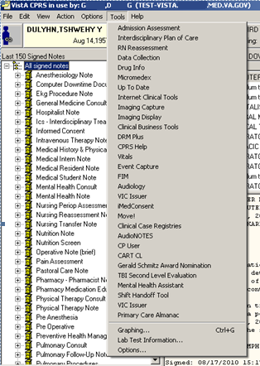
Access through CPRS

- Type the patient name in the Enter a patient text box.
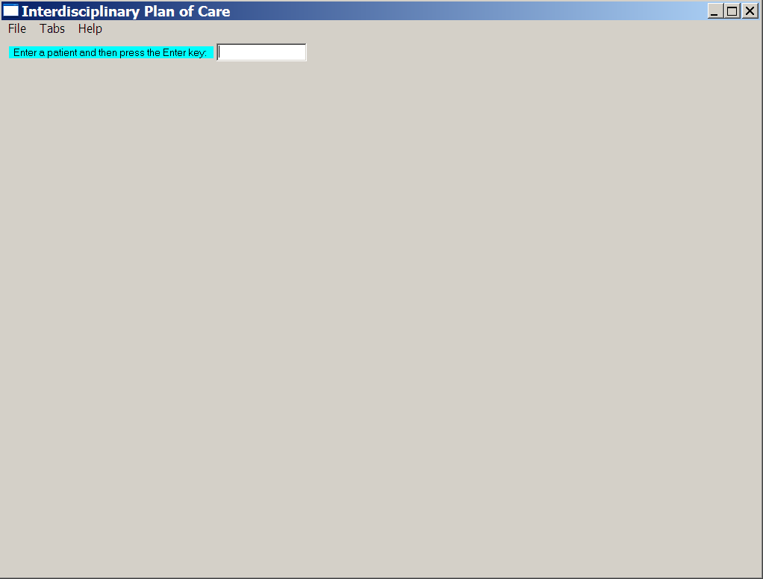
Interdisciplinary Plan of Care, Enter a patient window
- Click OK.
Gen Inf 1 displays.
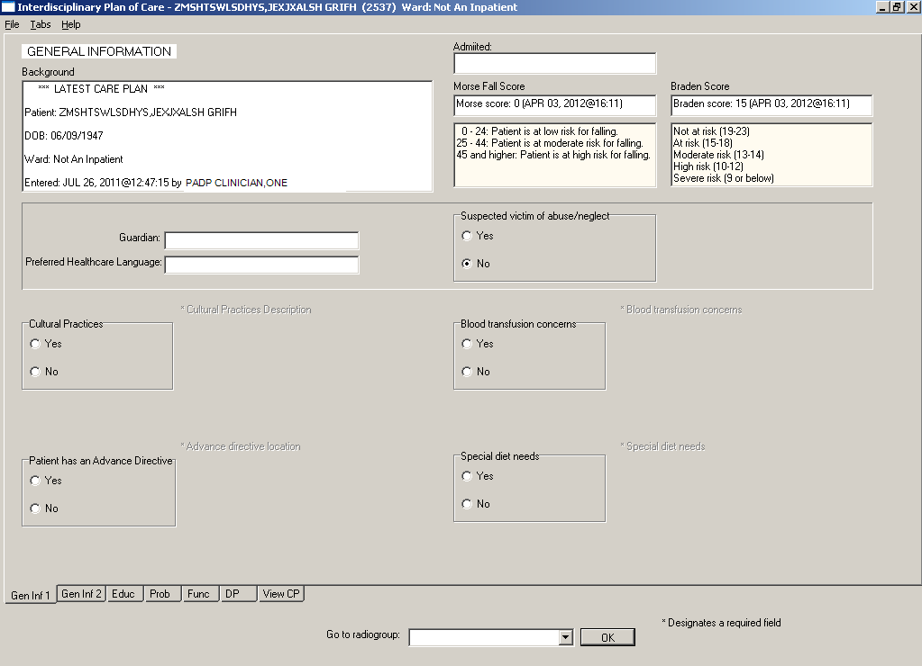
Interdisciplinary Plan of Care, General Information Gen Inf 1 tab window

Saving and Uploading Data
The initial plan of care is generated using data entered on the Care Plan (CP) pages while documenting in the Admission - RN Assessment template.
Note: When you upload data from the Admission - RN Assessment and/or the RN Reassessment, that data is also sent to the Interdisciplinary Plan of Care.

Auto Save
Data is saved automatically. Frequency of auto save is set locally.
Saving data: percentage saved indicator
(bottom right corner of the window)

Upload Data
To create a note you must upload the data to VistA and CPRS:
- Open the File menu on any tab and select Upload Data.
Warning pop-up displays.
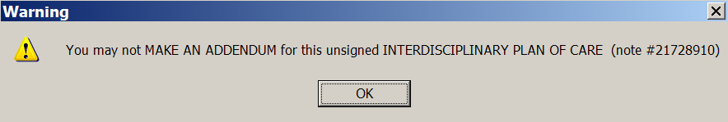
Warning pop-up: You may not MAKE AN ADDENDUM for this unsigned
INTERDISCIPLINARY PLAN OF CARE (note #21728910)
- Click OK.
Error found message displays.
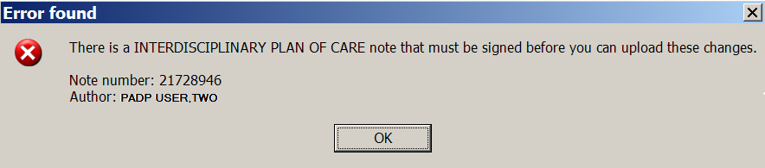
Error found: There is a Interdisciplinary plan of care note that must be signed
before you can upload these changes.
- Click OK.

- If required fields are incomplete, an Error Listing displays indicating the tab and issues that require attention.
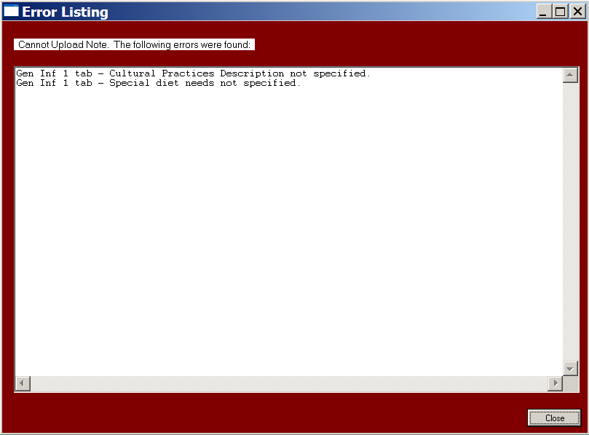
Error Listing window
- Double-click an item to go to the tab that requires attention.
- When all the errors are completed, select Upload Data again.

Exit
- From any tab, click X in the top right corner of the window.
Warning message displays.
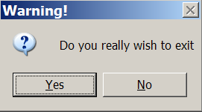
Warning pop-up: Do you really wish to exit?
- Click Yes.
or
- From any tab, open the File menu and click Exit.
Warning message displays.
- Click Yes.

Working in the Template
- To complete the template, move through the fields from left to right and then down.
- Each field with an asterisk (*) must have an entry.
- A field without an asterisk is optional.

Moving through the Template with a Mouse
- Click a tab at the bottom of any of the Interdisciplinary Plan of Care windows.
The selected tab opens.
Interdisciplinary Plan of Care tabs
- Open the Tabs menu and select a tab from the list.
The selected tab opens.
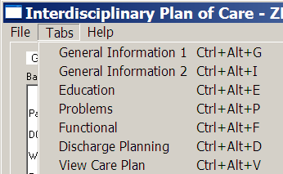
Interdisciplinary Plan of Care, Tabs menu

Moving through the Template without a Mouse

Ctrl-Alt Keys
You can move from tab to tab using Ctrl+Alt+<letter>. The list contains the keys to use for each of the tabs.

Tab | Keys
General Information 1 | Ctrl +Alt+G
General Information 2 | Ctrl +Alt+I
Education | Ctrl +Alt+E
Problems | Ctrl +Alt+P
Functional | Ctrl +Alt+F
Discharge Planning | Ctrl +Alt+D
View Care Plan | Ctrl +Alt+V

Go to radiogroup
The Go to radiogroup: is designed to navigate the templates with keyboard commands, when the mouse stops working during a patient assessment. It also satisfies the 508-compliant requirement, under Section 508 of the Rehabilitation Act, to be able to navigate the templates without using a mouse.
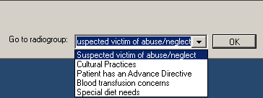
Go to radiogroup
- Use the Tab key to move to the bottom of the page.
- Use the arrow keys to move up/down in the Go to radiogroup: list.
- Click OK.
or
- Click the drop-down arrow in the Go to radiogroup: drop-down list.
- Select a radiogroup.
- Click OK.

Navigating the Interdisciplinary Plan of Care Tabs
The Interdisciplinary Plan of Care template has seven tabs.

General Information 1 (Gen Inf 1)
The Interdisciplinary Plan of Care template opens to the General Information 1 (Gen Inf 1) tab, the first tab at the bottom on the left. The Gen Inf 1 tab pulls information from the Admission – RN Assessment or a previous Interdisciplinary Plan of Care.

The Gen Inf 1 tab contains:
- Background
Pulled from the Admission – RN Assessment and other VistA files and cannot be edited
- Admitted
Date and time patient is admitted
- Morse Fall Score
Pulled from previously entered data and cannot be edited from the Plan of Care
- Braden Score
Pulled from previously entered data and cannot be edited from the Plan of Care
- Guardian
- Preferred Healthcare Language
- Suspected victim of abuse/neglect
- Cultural Practices
- Blood transfusion concerns
- Patient has an Advance Directive
- Special diet needs
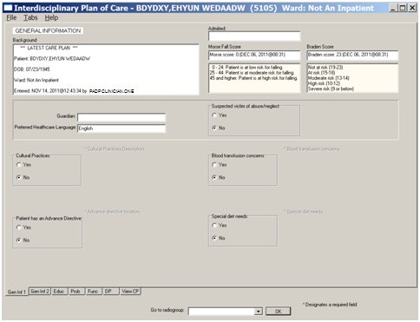
Interdisciplinary Plan of Care, General Information, Gen Inf 1 tab window
- On the Gen Inf 1 tab, make changes if necessary.
- Click Gen Inf 2.
Gen Inf 2 displays.

Example
If a Patient has an Advance Directive, you can change No to Yes. Advance directive location becomes available and because it is required, you can document the current location of Advance Directive.

General Information 2 (Gen Inf 2)
The General Information 2 tab pulls information from the Admission – RN Assessment or a previous Interdisciplinary Plan of Care. The Gen Inf 2 tab is read-only.

The Gen Inf 2 tab contains:
- Allergies
- Current Inpatient Meds (last 3 days)
- Precautions/Flags
- Current Active or Pending orders since yesterday
- Display only orders entered since yesterday (checked/unchecked)
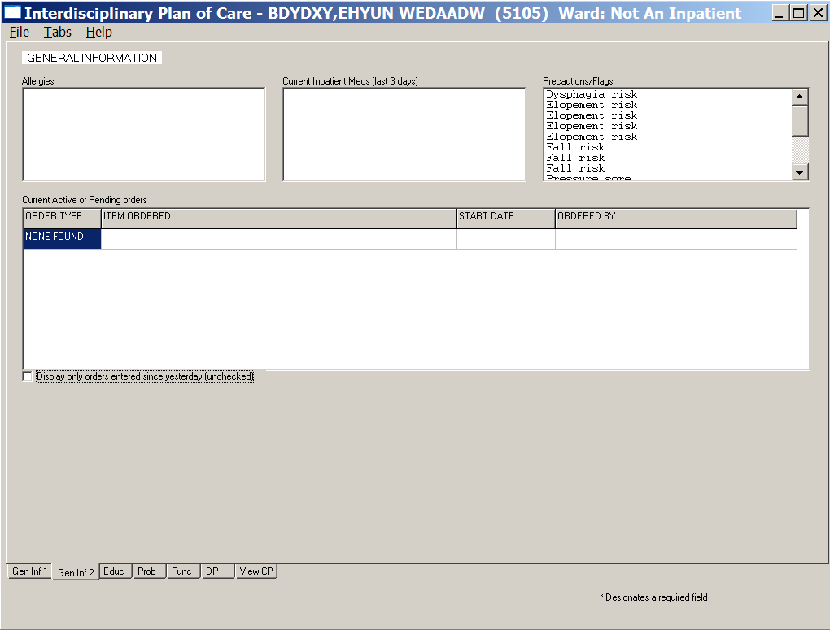
Interdisciplinary Plan of Care, General Information, Gen Inf 2 tab window
Review the information in the Gen Inf 2 tab; no changes can be made on Gen Inf 2.

Education (Educ)
The Education tab pulls in previously entered information. You can change the responses, if the patient’s condition requires education modifications.

The fields are like the Educational Assessment in the Admission - RN Assessment and the RN Reassessment.
- Patient/family/support person oriented
- Able to assess education
- Learns best by
- Prefers (method of learning)
- Readiness to learn
- Barriers to learning
- Knowledge of current illness, surgery, reason for hospitalization etc. as identified by patient
- Information provided to patient on the following topics
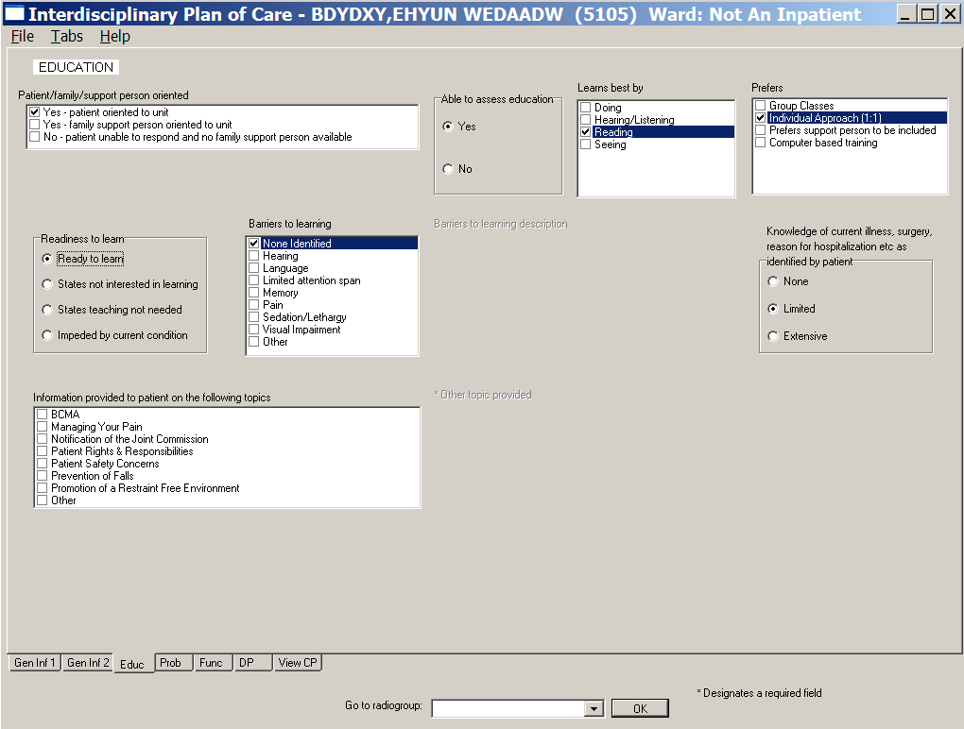
Interdisciplinary Plan of Care, Education, Educ tab window
In the Educ tab, make changes if necessary.

Problems/Interventions/Desired Outcomes (Prob)
Problems are listed in the table on the Problems/Interventions/Desired Outcomes (Prob) tab.
You can view:
- All problems for the current hospitalization of the patient, including resolved problems, or
- Only active problems
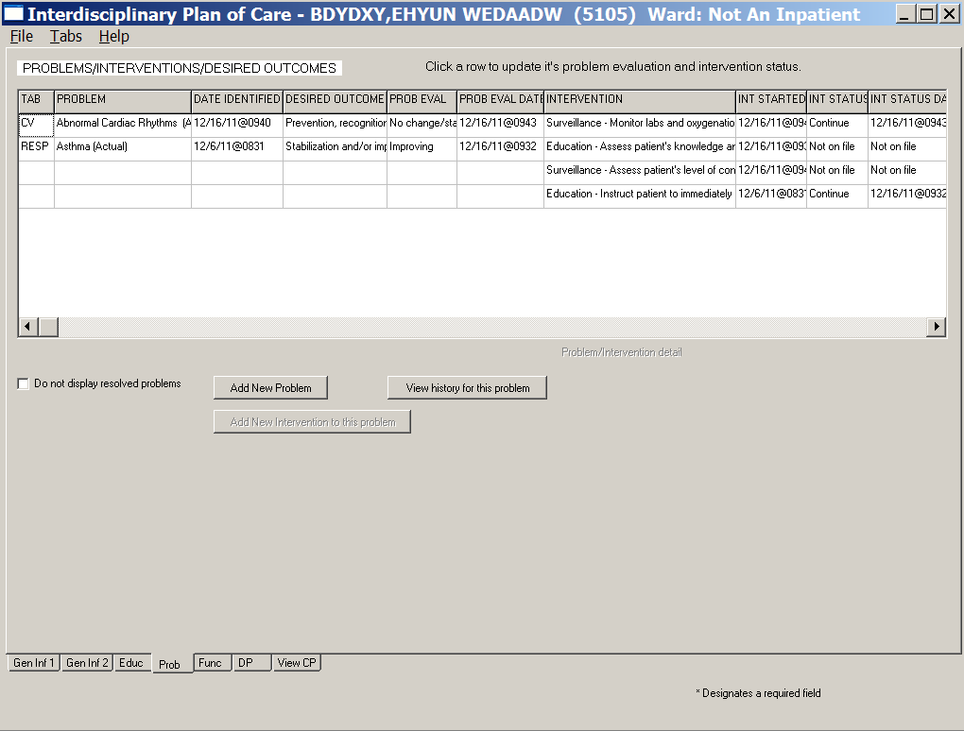
Interdisciplinary Plan of Care, Problems/Interventions/Desired Outcomes, Prob tab window
Note: To switch between the two views, select or clear the Do not display resolved problems check box.

Care Plan Table
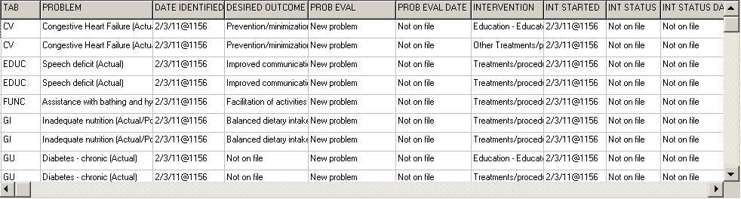
Interdisciplinary Plan of Care, Problems/Interventions/Desired Outcomes table
The width of each Prob tab column is adjustable. There are ten columns in the Care Plan (Problems/Interventions/Desired Outcomes) table.

Column Name | Description
Tab | Tab in which the problem was identified in a previous assessment  Example  The problems came from the Mental Health Assessment, MH tab.
Problem | Problem of concern from a previous assessment
Date Identified | Date the problem was identified
Desired Outcome | Preferred resolution of the problem
Prob Eval  (Problem Evaluation) | In relation to the problem, how are things going?  - No change/Stable  - Deteriorating  - Improving  - Resolved  - Unresolved at discharge
Prob Eval Date  (Problem Evaluation Date) | Date on which the problem was last evaluated
Intervention | The what to do for the patient you identify, so that the problem will improve/get better/not get worse
Int Started  (Intervention Started) | Date on which the intervention was initiated
Int Status  (Intervention Status) | In relation to the intervention, how should the staff proceed?  - Complete  - Continue  - Discontinue  - Pending (intervention was ordered but not started, such as a special bed or a lab test)  - Not on file (status not evaluated)
Int Stat Date  (Intervention Status Date) | Date on which the status of the intervention was evaluated

Updating an Existing Problem/Intervention
- Click a problem.
Problem evaluation and Intervention status become available.
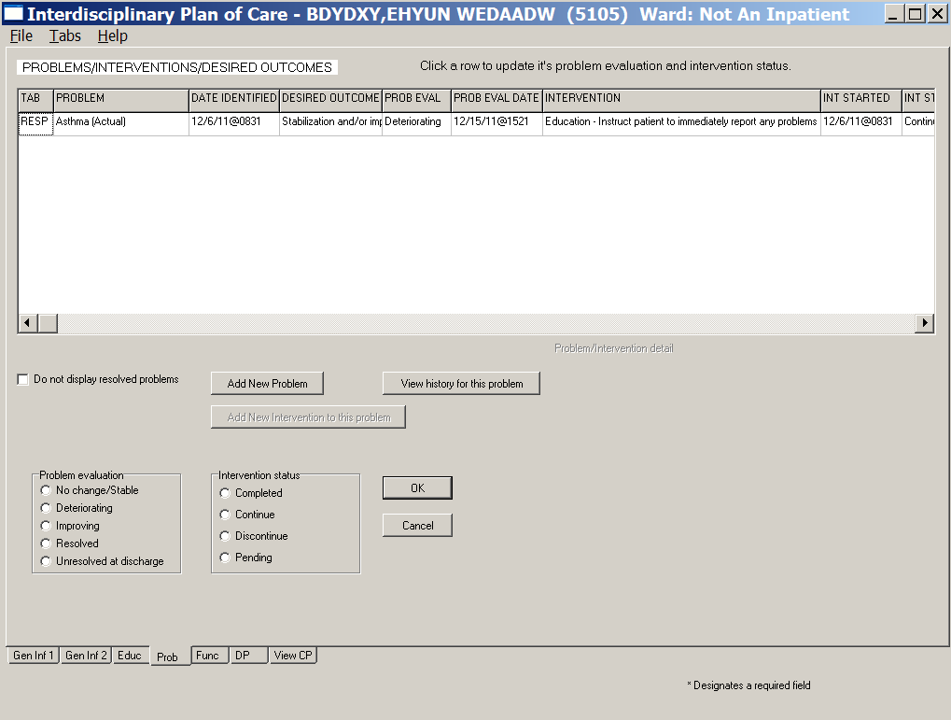
Interdisciplinary Plan of Care, Problems/Interventions/Desired Outcomes, Prob tab window
Problem evaluation and Intervention status available
- Click the problem again to view its Problem/Intervention detail.
A summary of the problem displays with the specific intervention and statuses.
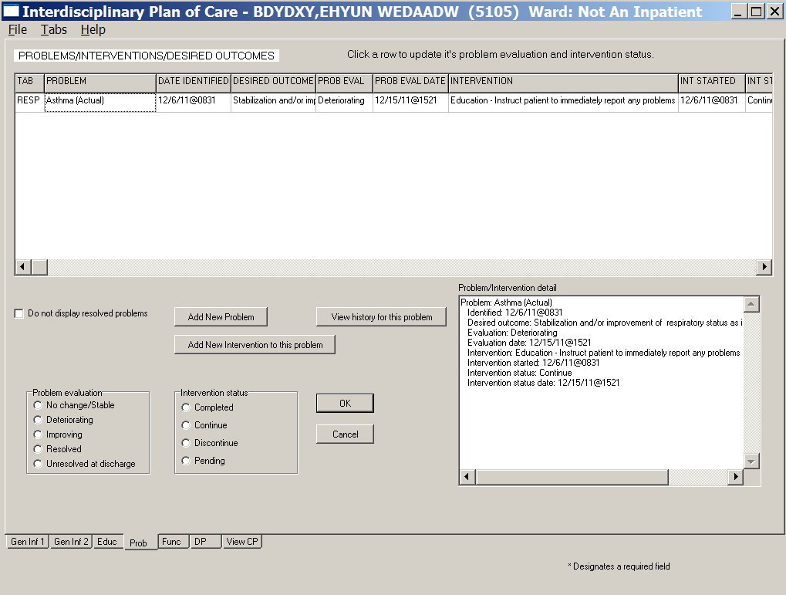
Interdisciplinary Plan of Care, Problems/Interventions/Desired Outcomes, Prob tab window
Problem/Intervention detail available
- Select a problem evaluation and an intervention status for a selected problem.
Evaluate both the problem and the specific interventions each time you document.
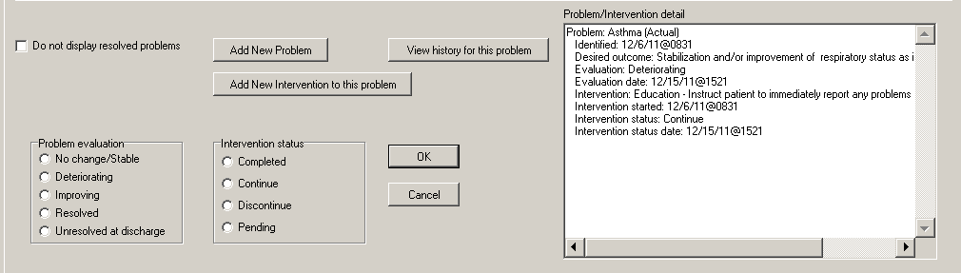
Problem evaluation, Intervention status, and Problem/Intervention detail
- To delete entered data before saving, click Cancel.
- Click OK.
Information pop-up displays.
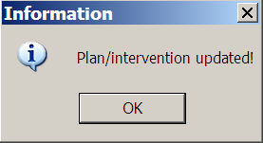
Information pop-up: Plan/Intervention updated!
- Click OK to complete the problem/intervention update.
- To update additional problems/interventions, repeat steps 1-6, as necessary.
- Review the care plan table.
The Prob Eval/Int Status are updated and the Prob Eval Date/Int Status Date are added.
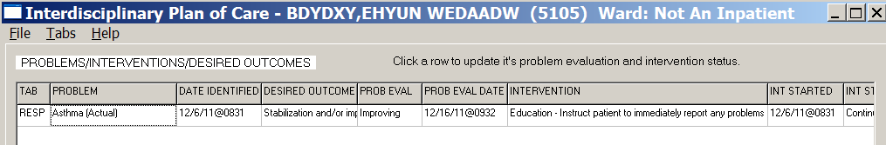
Interdisciplinary Plan of Care, Problems/Interventions/Desired Outcomes, Prob tab window
with an updated problem
- Click View history for this problem to view the history of the selected problem.
The Problem History displays.
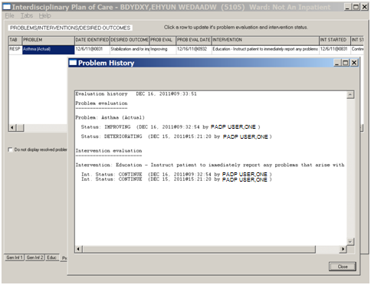
Problem History window
- Click Close.

Adding a New Intervention for an Existing Problem
- Click a problem.
- Click Add New Intervention to this problem.
The Add New Problem/Intervention window displays with the area and problem selected.
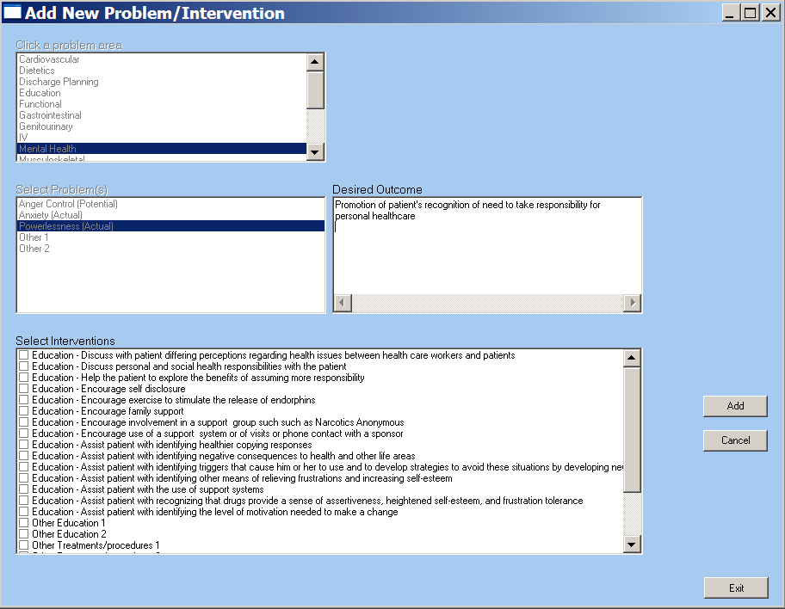
Add a New Problem/Intervention window
- Select one or more interventions from the Select Interventions list box.
- Click Add.
Information pop-up displays.
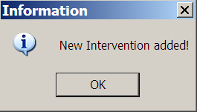
Information pop-up: New Intervention added!
- Click OK.
- Click Exit.
Information pop-up displays.
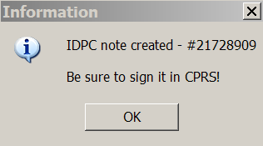
Information pop-up: IDPC note created - #(21728909)
Be sure to sign it in CPRS!

- Click OK.
Problems/Interventions/Desired Outcomes window redisplays with the new intervention.
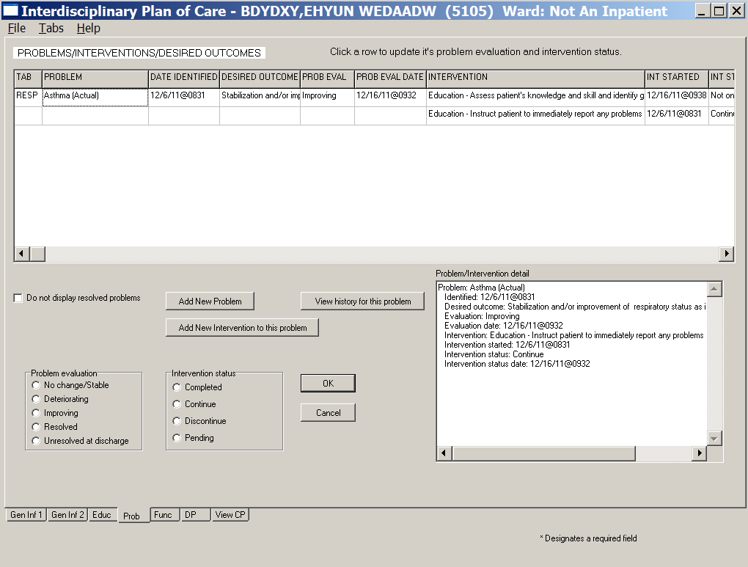
Interdisciplinary Plan of Care, Problems/Interventions/Desired Outcomes, Prob tab window
with a new intervention added
- To add more interventions, repeat steps 1-7.

Adding a New Problem/Intervention
- Click Add New Problem.
Add New Problem/Intervention window displays.
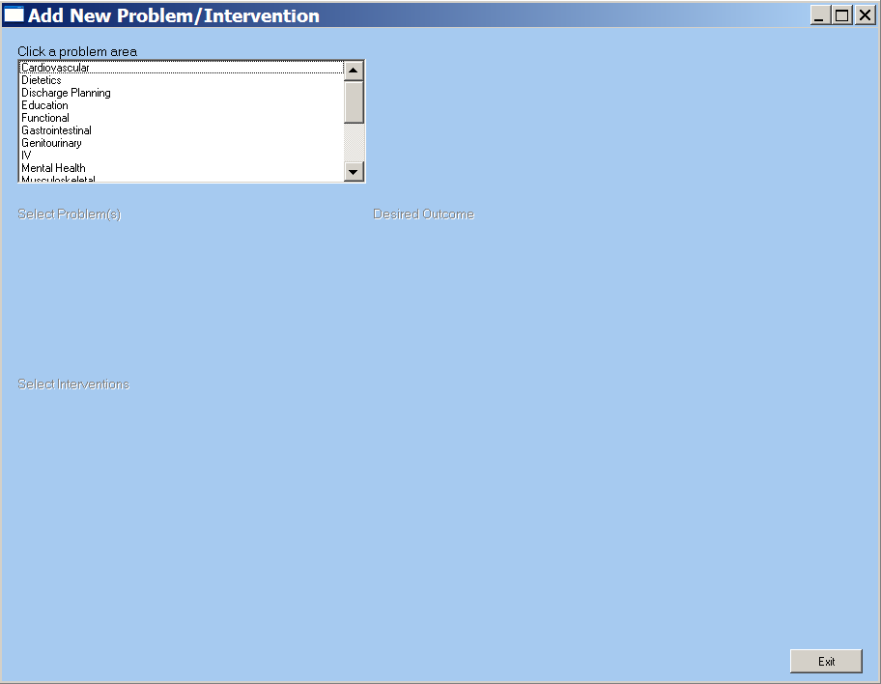
Add New Problem/Intervention window
- Select an area from the Click a problem area list box.
The Select Problem(s) list box displays.
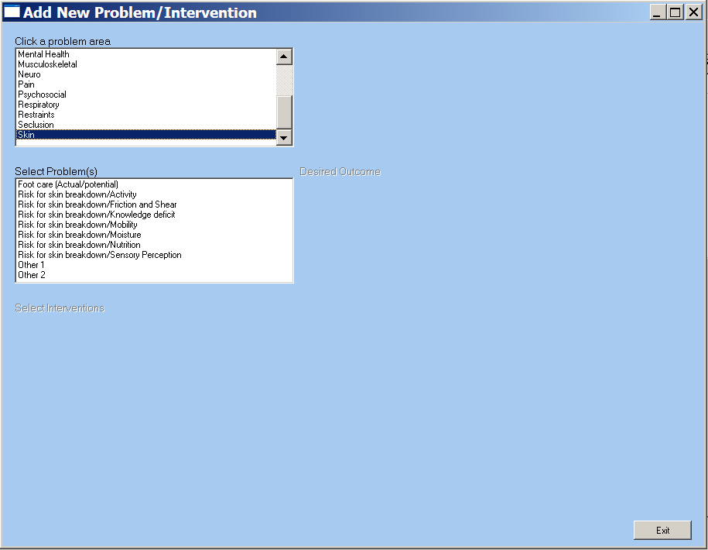
Add New Problem/Intervention window
Select Problem(s) available
- Select a problem from the Select Problem(s) list box.
You can select only one problem at a time.
The Desired Outcome text box and the Select Interventions list box display.
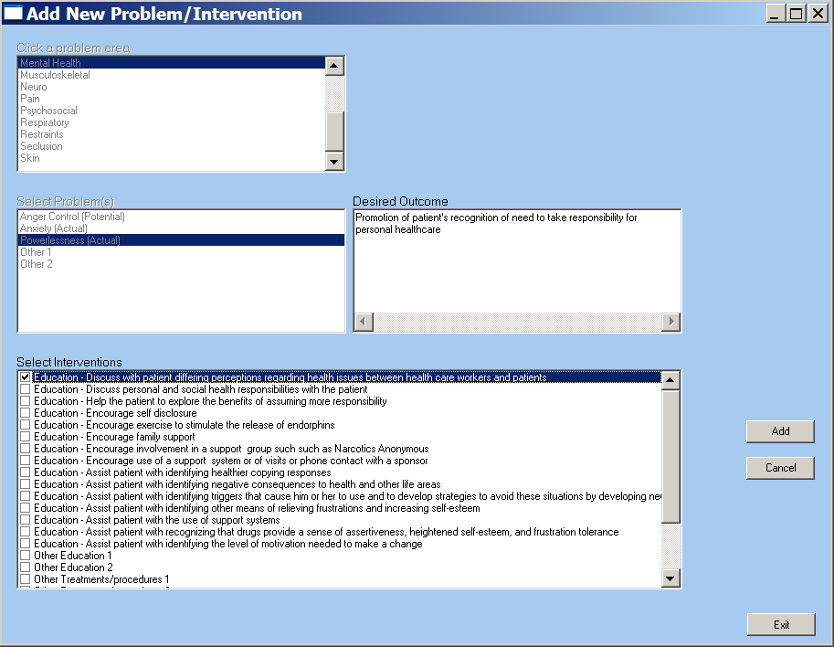
Add New Problem/Intervention window for problem/intervention options
- Select an intervention from the Select Interventions list box.
- Click Add.
Information pop-up displays.
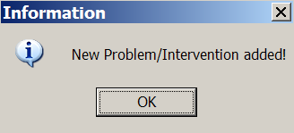
Information pop-up: New Problem/Intervention added!
- Click OK.
- Click Exit.
Information pop-up displays.
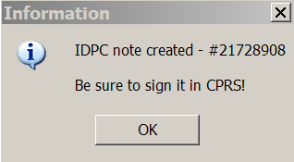
Information pop-up: IDPC note created - #(21728908)
Be sure to sign it in CPRS!
- Click OK.
Note: The Prob tab redisplays with the new problem and its related intervention(s) added to the table (grouped according to tab).
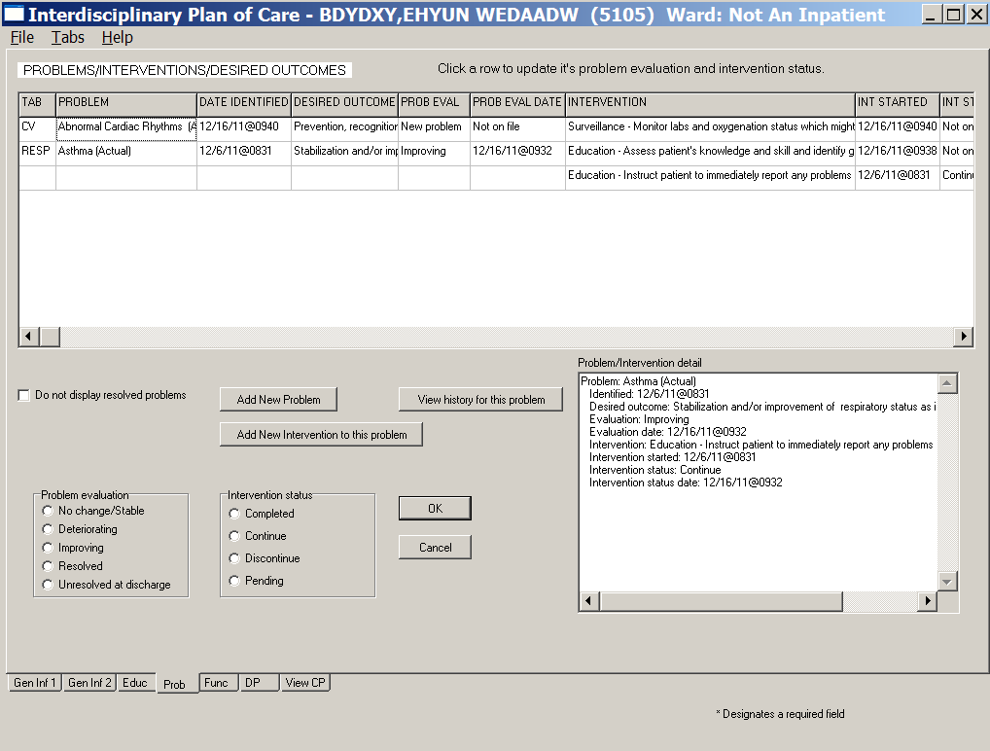
List of Problems/Interventions/Desired Outcomes with new problem added
- To add more problems/interventions, repeat steps 1-8, as necessary.

Other Problems
Some problems generate a pop-up to enter problems that are not on the predefined list.
- Select an Other problem in the Select Problems list box.
The Other problems pop-up displays.
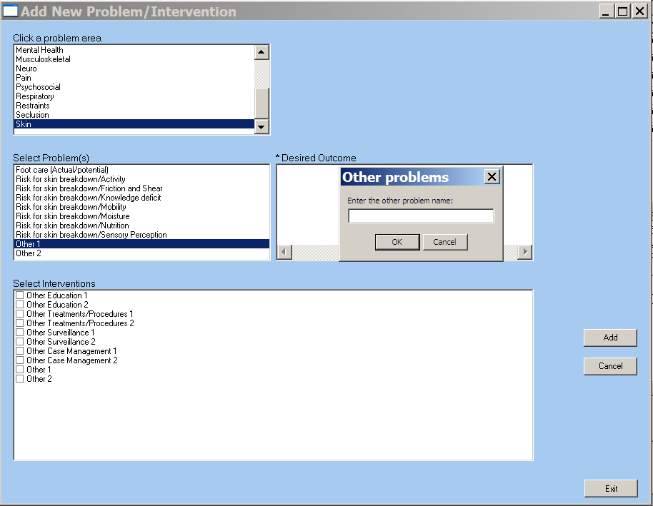
Add New Problem/Intervention window with Other pop-up
- Type the other problem into the text box.
- Click OK.
Information pop-up displays.
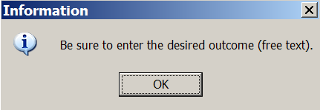
Information pop-up: Be sure to enter the desired outcome (free text).
- Click OK.
- Type a desired outcome into the Desired Outcome text box.
- Select one or more interventions from the Select Interventions list box.
- Click Add.
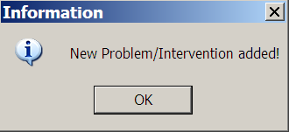
Information pop-up: New Problem/Intervention added!
- Click OK.
- Click Exit.
- To add more other problems, repeat steps 1-9, as necessary.

Other Interventions
Some interventions generate a pop-up to enter interventions that are not on the predefined list.
- Select an Other intervention in the Select Interventions list box.
The Other intervention pop-up displays.
- Type the other intervention into the text box.
- Click OK.
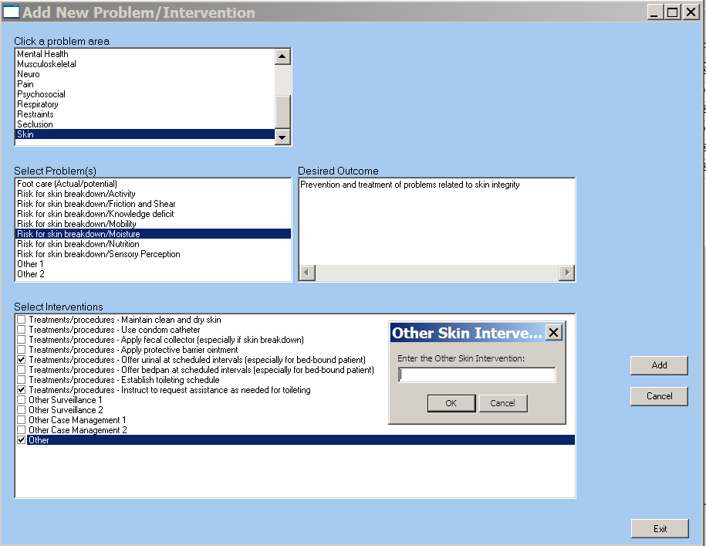
Add New Problem/Intervention window with Other pop-up
- Click Add to transfer the intervention to the plan of care.
Information pop-up displays.
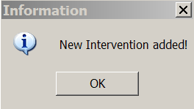
Information pop-up: New Intervention added!
- Click OK.
- Click Exit.
Information pop-up displays.
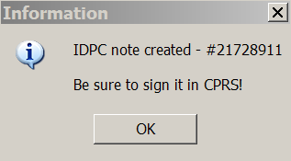
Information pop-up: IDPC note created - #(21728911)
Be sure to sign it in CPRS!
- Click OK.
- To add more other interventions, repeat steps 1-7, as necessary.

Functional (Func)
The Functional Assessment tab contains the information that you need to transfer a patient safely, using mechanical lifting devices and approved aids for lifting, transferring, repositioning, and moving patients.
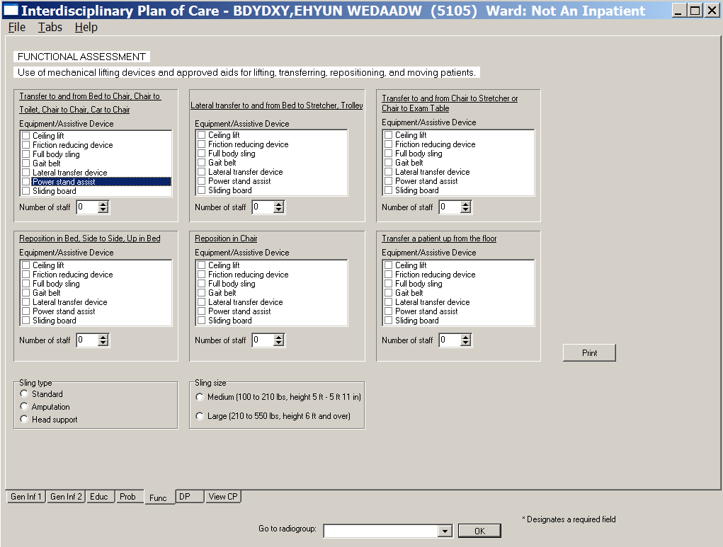
Interdisciplinary Plan of Care, Functional Assessment (Func) tab window
- Select one or more for each type of transfer, type of device, and number of staff needed.
- Select a sling type and sling size, if necessary.
- Click Print.
- Print the information and give it to the staff handling the transfer.

Discharge Planning (DP)
The Discharge Planning tab contains issues pulled forward into the list of Current discharge planning issues, identified previously in the Admission – RN Assessment or older plans of care.
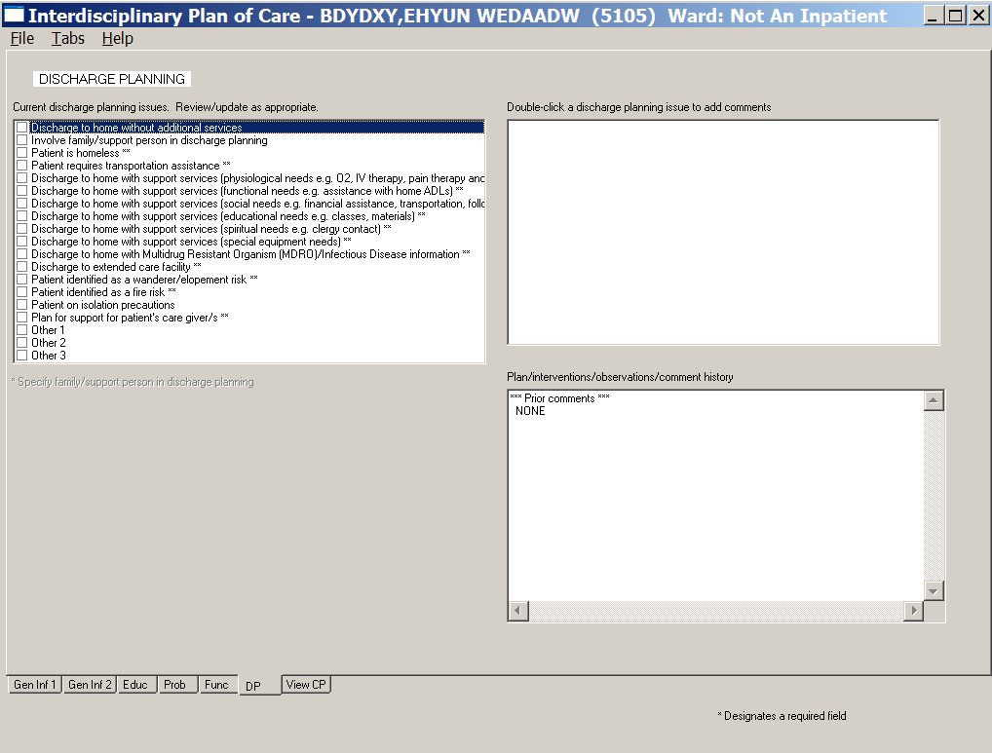
Interdisciplinary Plan of Care, Discharge Planning (DP) tab window
- Select one or more items in the Current discharge planning issues list box.
As you select an item, it moves to the comment text box on the right.

- Review the discharge planning issues and modify, as appropriate, based on the current situation.
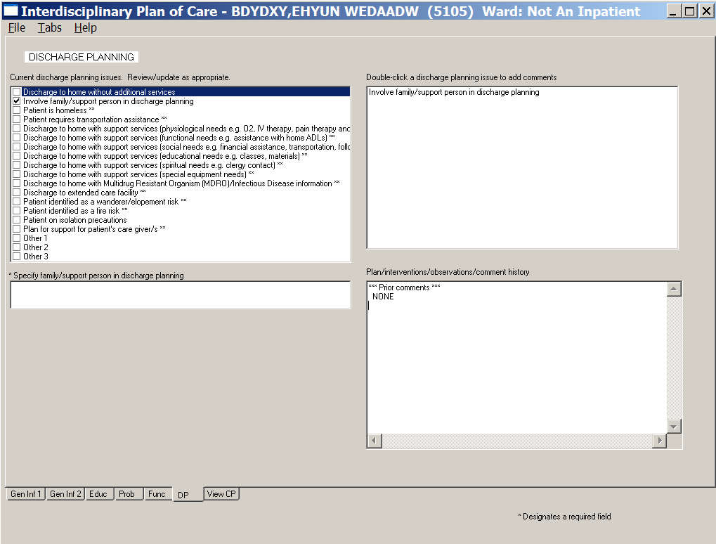
Interdisciplinary Plan of Care, Discharge Planning (DP) tab window
Involve family/support person in discharge planning selected

- To add comments for a selected discharge issue, double-click the discharge planning issue.
Discharge Planning Comments window displays.
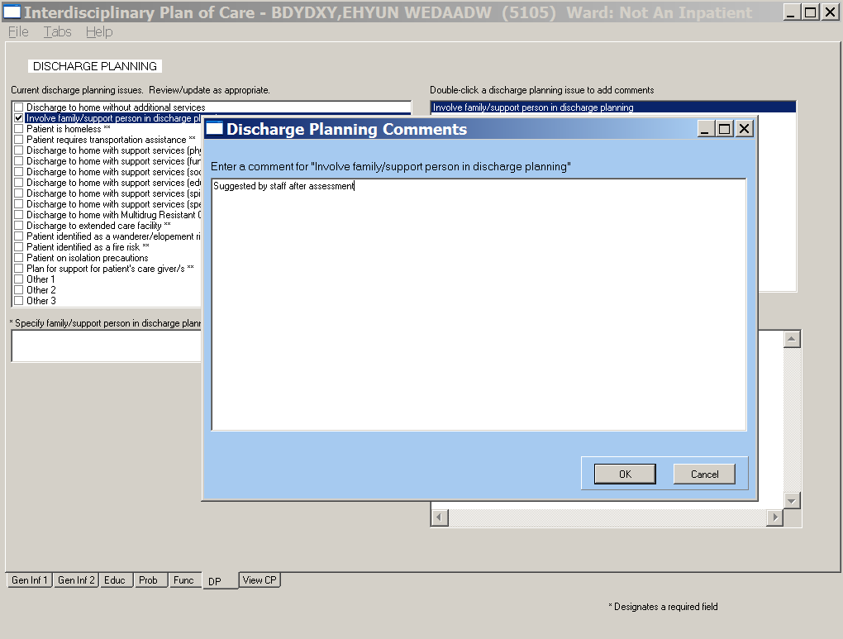
Discharge Planning Comments window
- Add a comment for the selected issue.

- Click OK.
Comments display in the Plan/interventions/observations/comments history along with the associated discharge planning issue and the name of the staff that entered the comment.
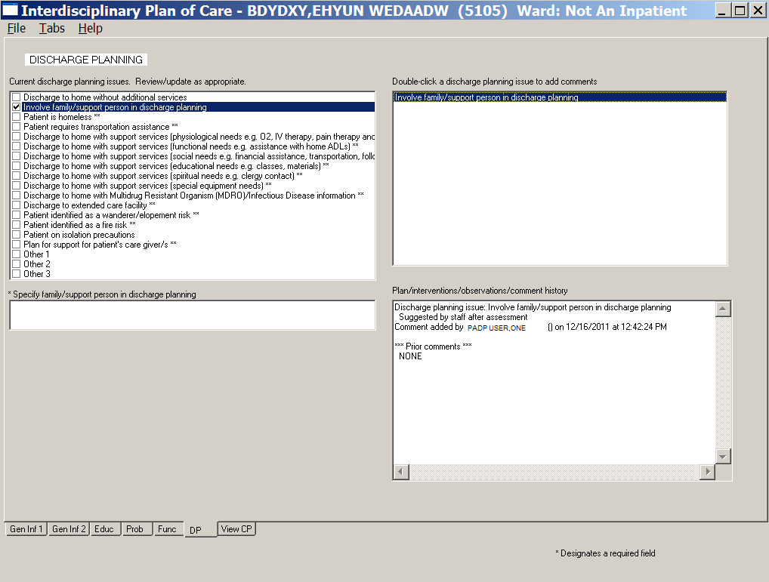
Interdisciplinary Plan of Care, Discharge Planning (DP) tab window

View Care Plan (View CP)
The View Care Plan (View CP) tab allows you to view and print three different perspectives of the Plan of Care.
- The Daily Plan®
The Daily Plan® is a summary of current orders for nurses, or other clinicians, to review daily with the patient, as appropriate. The RN can print a copy of The Daily Plan® for the patient by selecting the Patient requests a copy of The Daily Plan® check box. The daily plan should be re-evaluated after each reassessment because patient status may change.
- Plan of Care
The Plan of Care contains general information and problems/interventions from the Interdisciplinary Plan of Care, Prob tab.
- Discharge Plan
The Discharge Plan contains information about home environment, living arrangements, special equipment, and other needs.
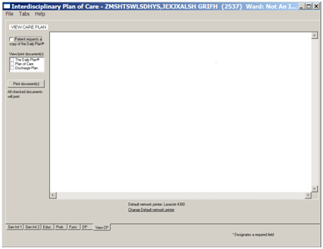
View Care Plan window: View/print documents menu

The Daily Plan®
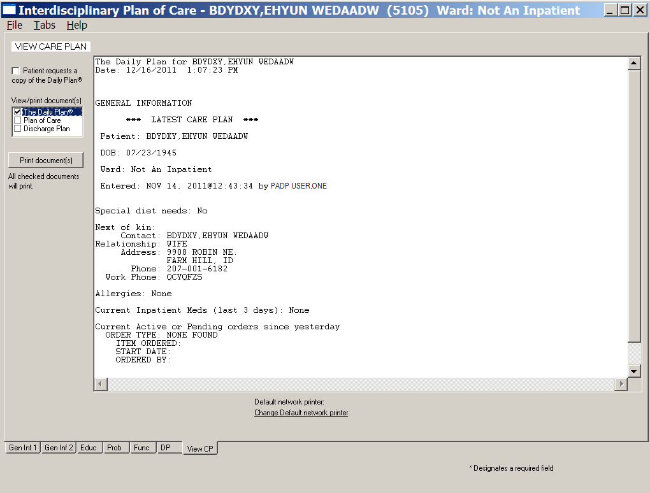
Interdisciplinary Plan of Care, Daily Plan
The Daily Plan® is a health summary that contains the following General Information components for the Latest Care Plan:
- Patient Name
- DOB (Date of Birth)
- Ward
- Entered (date/time)
- Special diet needs
- Next of kin
- Contact
- Relationship
- Address
- Phone
- Work phone
- Allergies
- Current Inpatient Meds (last 3 days)
- Current Active or Pending orders since yesterday
- Order type
- Item ordered
- Start date
- Ordered by
- Appointments in the next year

Plan of Care
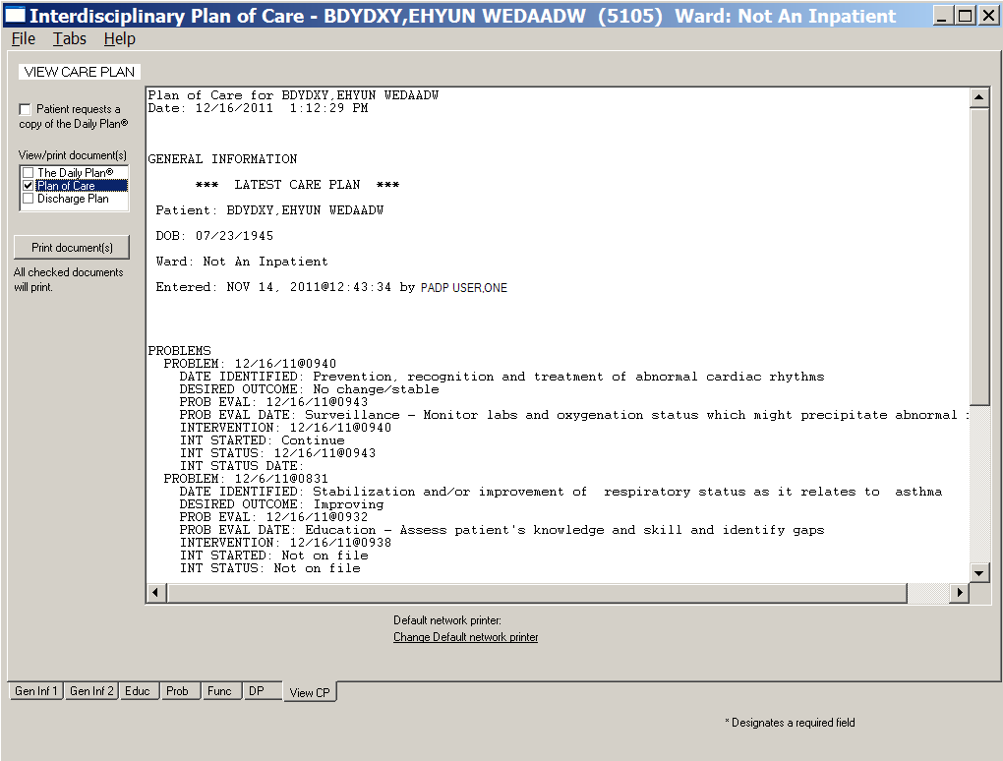
Interdisciplinary Plan of Care, Plan of Care
The Plan of Care includes General Information components for the Latest Care Plan:
- Patient
- DOB (Date of Birth)
- Ward
- Entered (date/time)
- Problems
- Problem
- Date identified
- Desired outcome
- Prob eval (evaluation)
- Prob eval (evaluation) date
- Intervention
- Int (intervention) started
- Int (intervention) status
- Int (intervention) status date

Discharge Plan
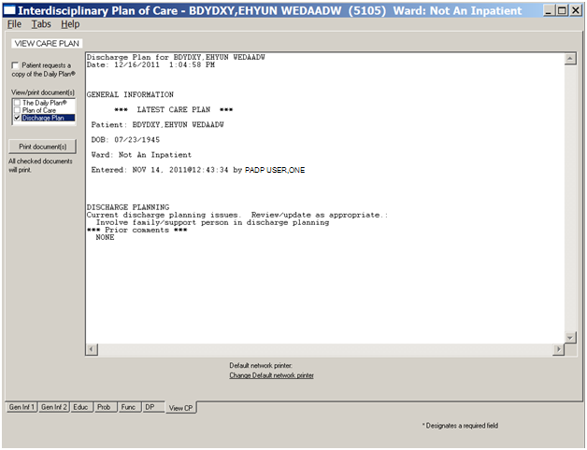
Interdisciplinary Plan of Care, Discharge Plan
The Discharge Plan includes General Information components for the Latest Care Plan:
- Patient
- DOB (Date of Birth)
- Ward
- Entered (date/time)
- Discharge Planning
- Current discharge planning issues
- Prior comments

Glossary
Term | Definition
ADPAC | Automated Data Processing Application Coordinator
ART | Adverse Reactions Tracking
BCE | Bar Code Expansion
BCE-PPI | Bar Code Expansion-Positive Patient Identification
BCMA | Bar Code Medication Administration
Belong | Belongings
CAC | Clinical Application Coordinator
CIWA | Clinical Institute Withdrawal Assessment.--CIWA
Class 1 (C1) | Software produced inside of the Office of Enterprise Development (PD) organization
Class 3 (C3) | Also known as Field Developed Software  Refers to all VHA software produced outside of the Office of Enterprise Development (PD) organization
CMS | Centers for Medicaid and Medicare Services
COTS | Commercial Off the Shelf
CP | Care Plan
CPRS | Computerized Patient Record System
CV | Cardiovascular Assessment
Delphi | Programming language used to develop the CPRS chart
DFN | Data File Number
DP | Discharge Planning
Educ | Educational Assessment
Func | Functional Assessment
Gen Inf | General Information tab
GI | Gastrointestinal Assessment
GU | Genitourinary Assessment
GUI | Graphical User Interface
ICD | International Classification of Diseases
ICN | The patient’s national identifier, Integration Control Number
IDPA | Interdisciplinary Patient Assessment - involves multiple disciplines responsible for assessing the patient from their perspective and expertise.
IDPC | Interdisciplinary Plan of Care - The entry of treatment plans by multiple disciplines to meet JCAHO requirements
IV | Intravenous
IV Central | Central IV lines
IV Dialysis | IV Dialysis ports
IV Periph | IV Peripheral lines
JCAHO | Joint Commission on Accreditation of Healthcare Organizations
LPN | Licensed Practical Nurse
M/S | Musculoskeletal Assessment
MAS | Medical Administration Service
MH | Mental Health Assessment
MRSA | Methicillin-Resistant Staphylococcus Aureus
NAA | Nursing Admission Assessment
Neuro | Neurological Assessment
NHIA | Nursing Healthcare Informatics Alliance
NPAT | National Patient Assessment Templates
NUPA | Namespace assigned to the Patient Assessment Documentation Package (PADP) by Database Administrator
OED | Office of Enterprise Development
OERR | Order Entry Results Reporting
OIT | Office of Information and Technology
ONS | Office of Nursing Services
Orient | Orientation to Unit
P/S | Psychosocial Assessment
PADP | Patient Assessment Documentation Package
Pain | Pain Assessment
PC | Plan of Care
PCE | Patient Care Encounter
PD | Product Development
PHR | Patient Health Record
Prob | Problems/Interventions/Desired Outcomes tab in the RN Reassessment
Resp | Respiratory Assessment
Rest (or Restr) | Restraints
RN | Registered Nurse
RPC | Remote Procedure Call
RSD | Requirements Specification Document
Section 508 | Under Section 508 of the Rehabilitation Act, as amended (29 U.S.C. 794d) Public Law 106-246 (http://va.gov/accessible) agencies must provide employees and members of the public who have disabilities access to electronic and information technology that is comparable to the access available to employees and members of the public who are not individuals with disabilities
Skin | Skin Assessment
SNOMED – CT | Systemized Nomenclature of Medicine Clinical Terms
TIU | Text Integration Utilities Program  All text in CPRS is stored in TIU
TJC | The Joint Commission
V/S | Vital Signs
VA | Department of Veterans Affairs
VAMC | Department of Veterans Affairs Medical Center
VANOD | VA Nursing Outcomes Database
VHA | Veterans Health Administration
VistA | Veterans Health Information Systems and Technology Architecture  An enterprise-wide information system built around an electronic health record used throughout the Department of Veterans Affairs medical system.
Vital Qualifiers | Provide detail in to the unit of measurement used with the vital signs.  Height in inches or centimeters?  Weight in pounds or kilograms?

For additional PADP information, refer to the user manuals for Admission - RN Assessment, RN Reassessment, and Admission - Nursing Data Collection.

Documentation for NUPA Version 1.0 is also available on
- VA Software Documentation Library in the Clinical Section
http://www4.va.gov/vdl/
- PADP SharePoint for NUPA Version 1.0 http://vaww.oed.portal.va.gov/programs/class3_to_class1/padp/field_development

